School Name
Mathematics Test 2017
Year 9 |  | Right Triangle Trigonometry | Calculator  Allowed Test
Skills and Knowledge Assessed:  - Use similarity to investigate the constancy of the sine, cosine and tangent ratios for a given angle in right - angled triangles (ACMMG223)  - Apply trigonometry to solve right - angled triangle problems (ACMMG224)  - Solve right- angled triangle problems including those involving direction and angles of elevation and depression (ACMMG245) |  |  | Name_________________
Section 1 Short Answer Section
Write all working and answers in the spaces provided on this test paper.

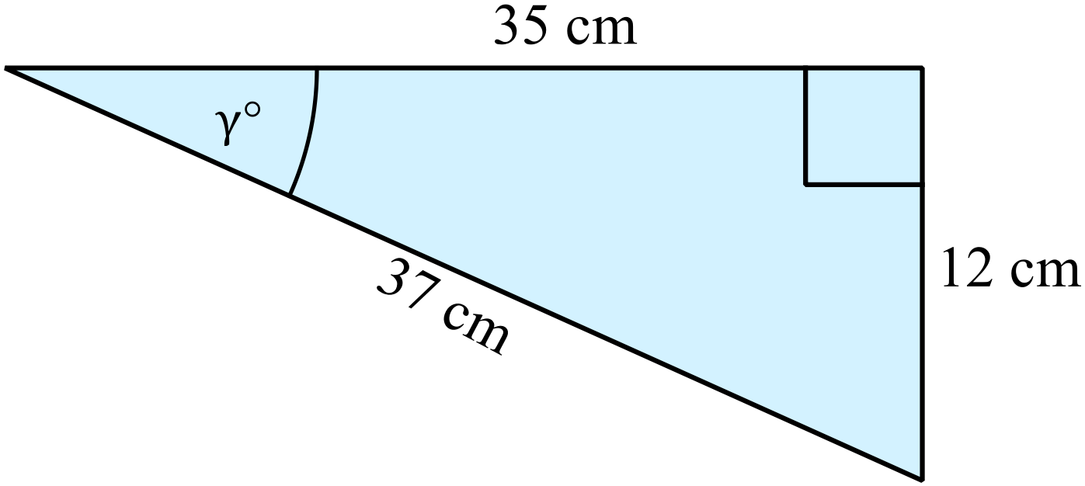In the diagram, what is the value of 

……………………………………………………

……………………………………………………
Calculate 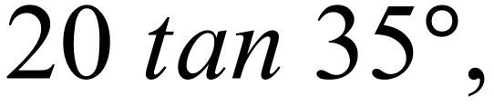 correct to 3 significant figures.

……………………………………………………………………………………………....

……………………………………………………………………………………………….
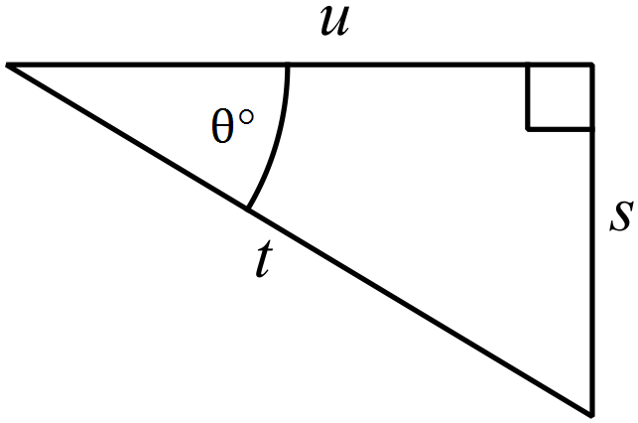Write an expression for 

………………………………………………

……………………………………………....

……………………………………………
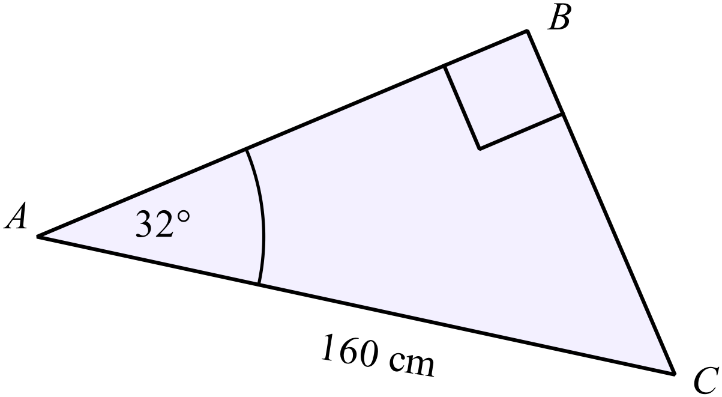What is the distance AB?
(Answer correct to 1 decimal place.)

………………………………………………

……………………………………………....

………………………………………………

……………………………………………….
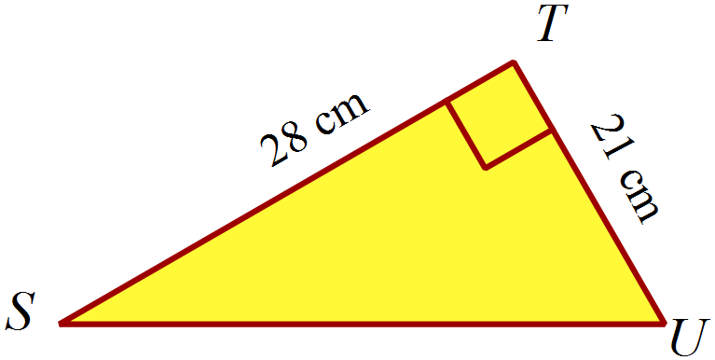Find the size of 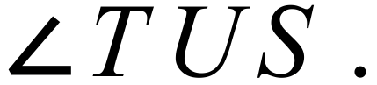

………………………………………………

……………………………………………....

………………………………………………

……………………………………………….
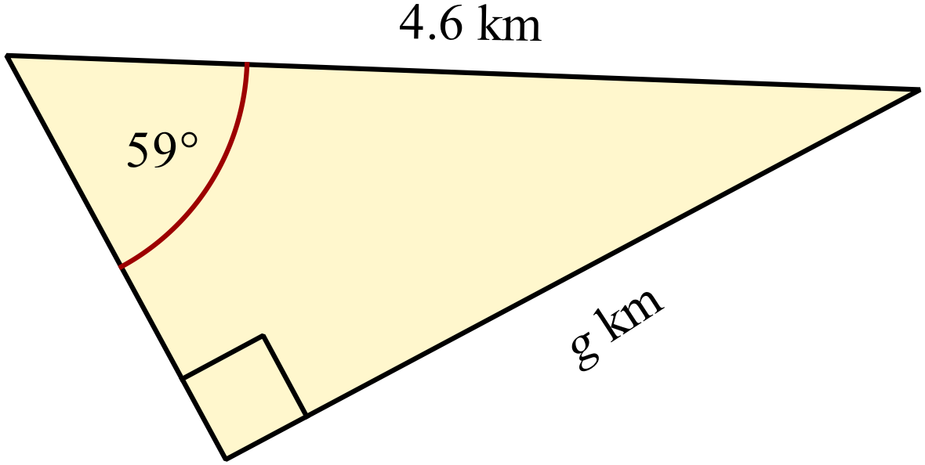Find the value of g correct to one decimal place.

……………………………………………....

………………………………………………

……………………………………………….
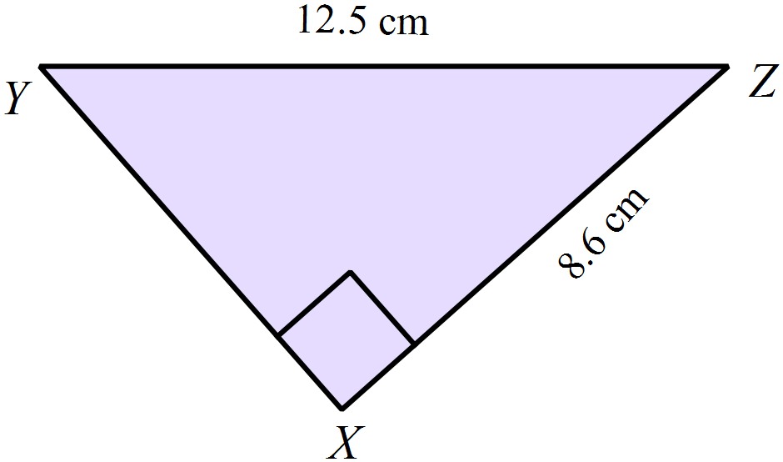Find the size of 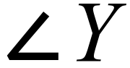 correct to the nearest degree.

………………………………………………

……………………………………………....

………………………………………………

……………………………………………….
Find the length of PQ correct to one decimal place.
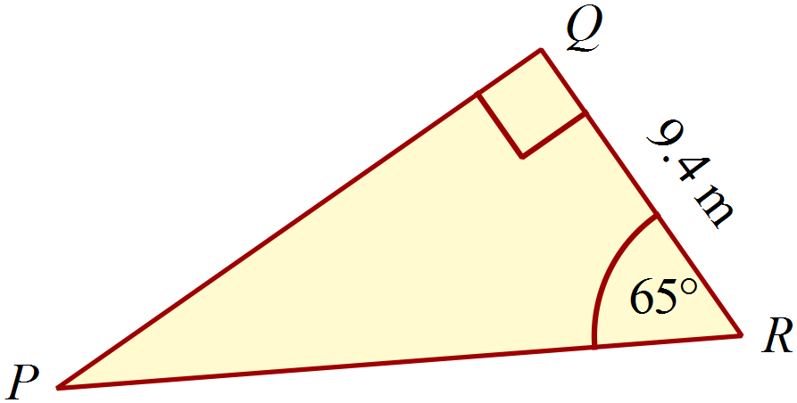

………………………………………………

……………………………………………....

………………………………………………

……………………………………………….
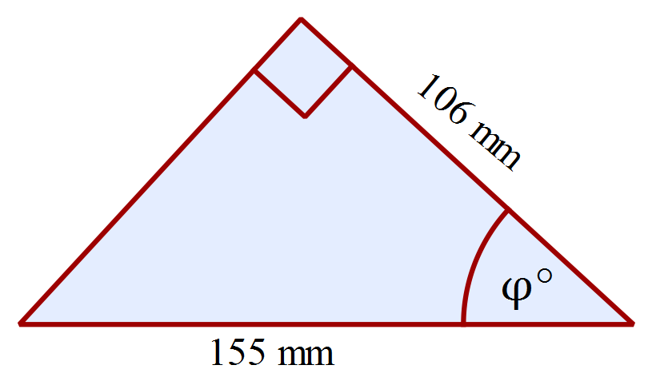What is the value of 

………………………………………………

……………………………………………....

………………………………………………

……………………………………………….
A helicopter (B) is hovering directly above C which is 500 m from A on level ground.
Radar at A measures the direct distance to the helicopter to be 650 m.
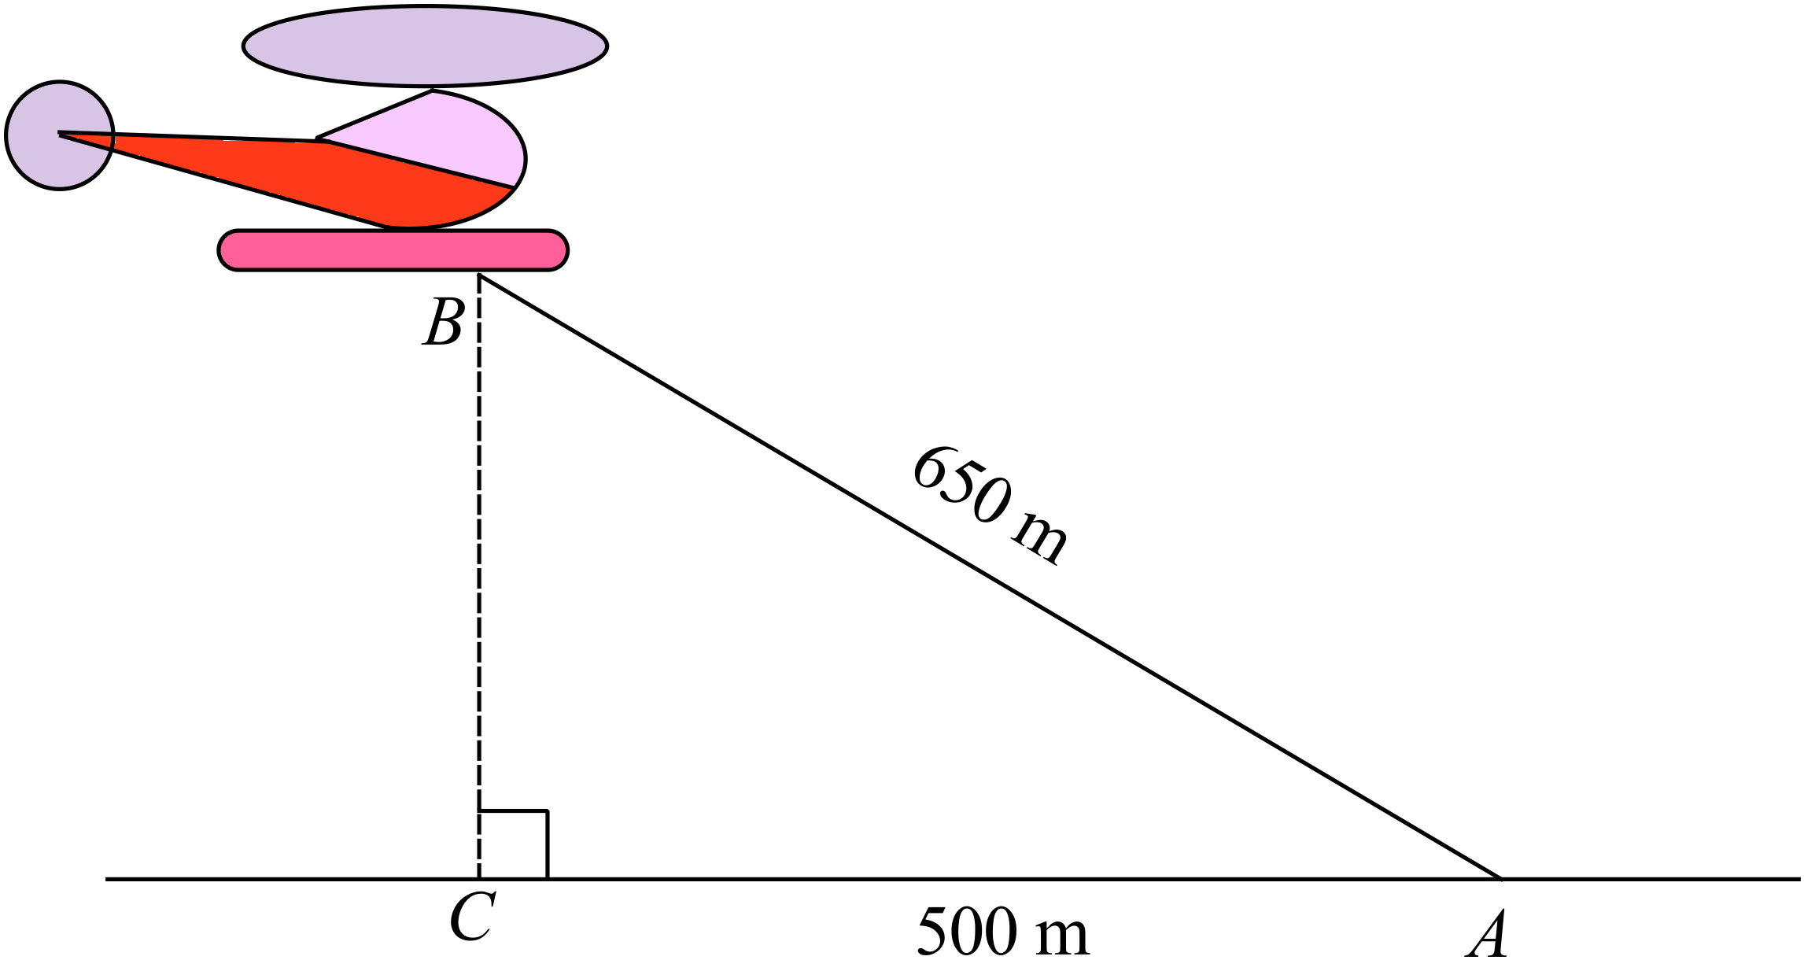What is the angle of elevation of B, when viewed from A?

………………………………………………

……………………………………………....

………………………………………………

……………………………………………….
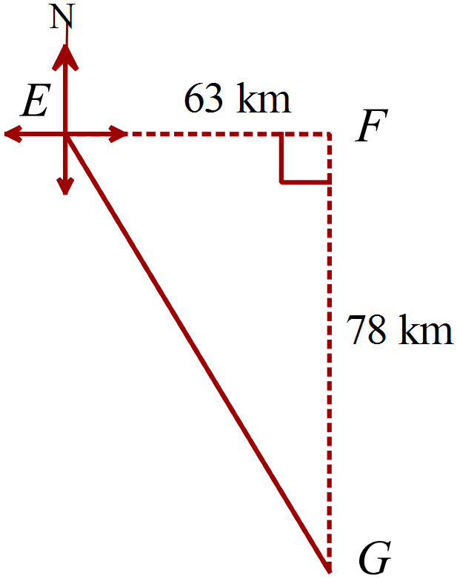EC = 63 km and FG = 78 km.
What is the bearing of G from E?

………………………………………………

……………………………………………....

………………………………………………

……………………………………………….

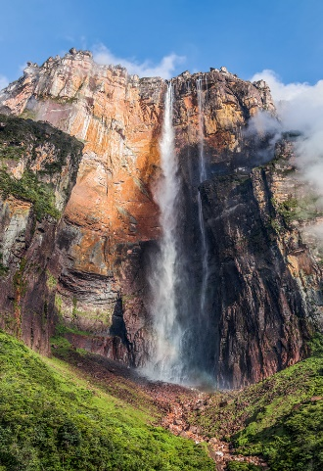
A geographer at Angel Falls, hikes 172.8 m back from the base of the falls and measures the angle of elevation of the top of the falls to be 80º.
Use this information to calculate the height of Angel Falls.

………………………………………………

……………………………………………....

………………………………………………

……………………………………………….

What is the value of d?
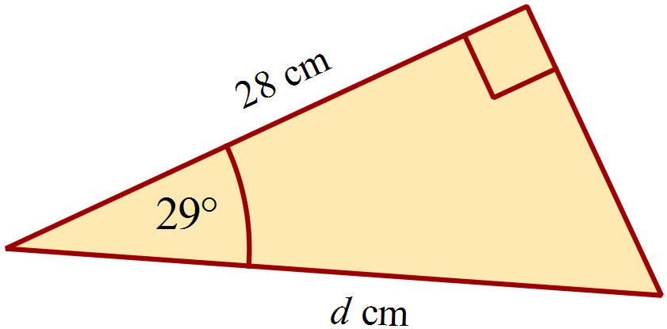(Answer to nearest 10th metre.)

………………………………………………

……………………………………………....

………………………………………………

……………………………………………….
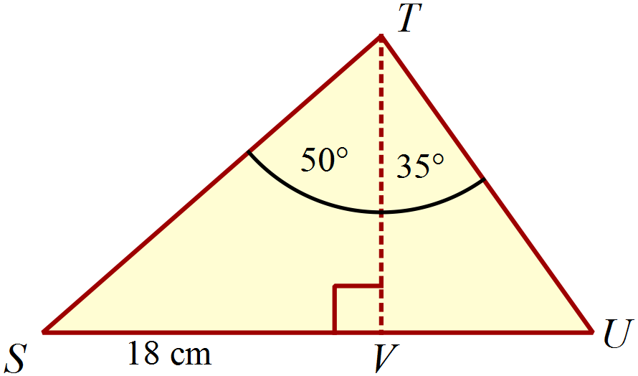In
Calculate the distance TU to the nearest mm.

………………………………………………

………………………………………………

………………………………………………

……………………………………………....

………………………………………………

……………………………………………….
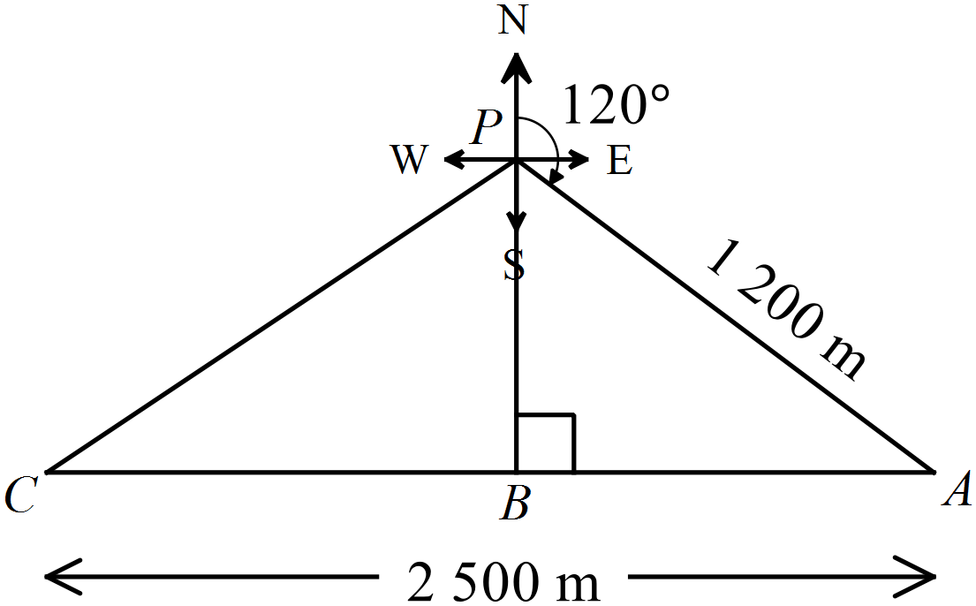Point A is 2500 km due east of point C.
Point B is between A and C and is due south of
point P.
Point A is 1200 m from P on a bearing of 120º.
What is the distance CB?

………………………………………………

………………………………………………

………………………………………………

……………………………………………....

………………………………………………

……………………………………………….

School Name
Mathematics Test 2017
Year 9 |  | Right Triangle Trigonometry | Calculator Allowed
 |  | Right Triangle Trigonometry | Name_________________
Section 2 Multiple Choice Section
Mark all your answers on the accompanying multiple choice answer sheet, not on this test paper. You may do any working out on this test paper. Calculators are allowed for this section.

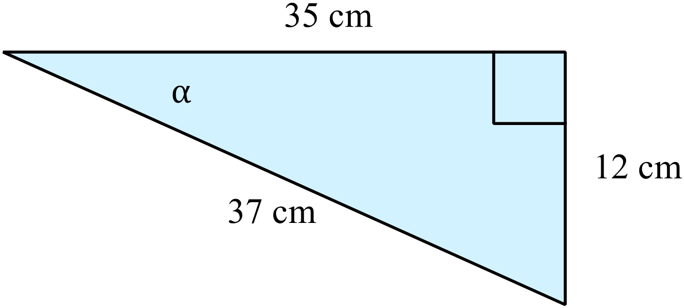In the diagram, what is the value of 

A. 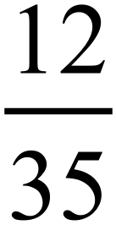
B. 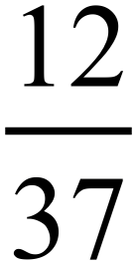
C. 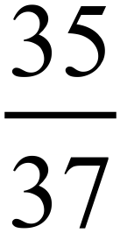
D. 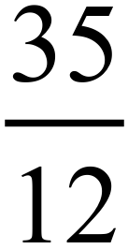
 | A. 7.39 B. 9.46 C. 15.23 D. 19.49
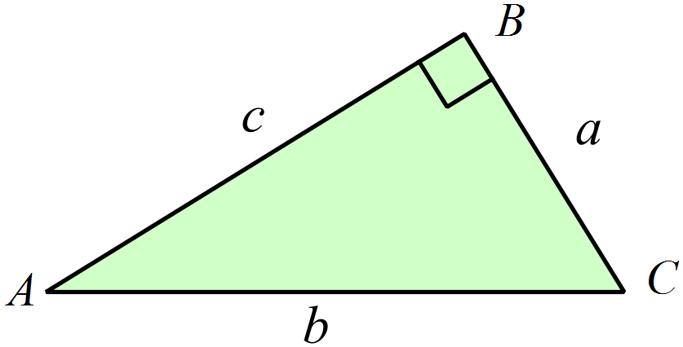In this triangle, which expression is equal to 

A. 
B. 
C. 
D. 
 | A. 21 B. 43 C. 47 D. 69
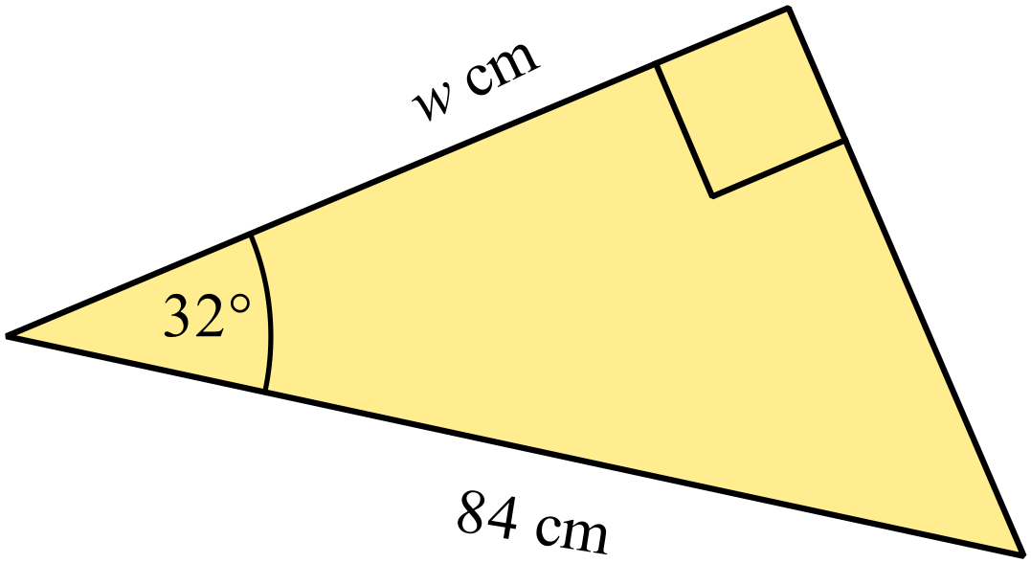What is the value of w?

A. 44.5
B. 52.5
C. 71.2
D. 99.1
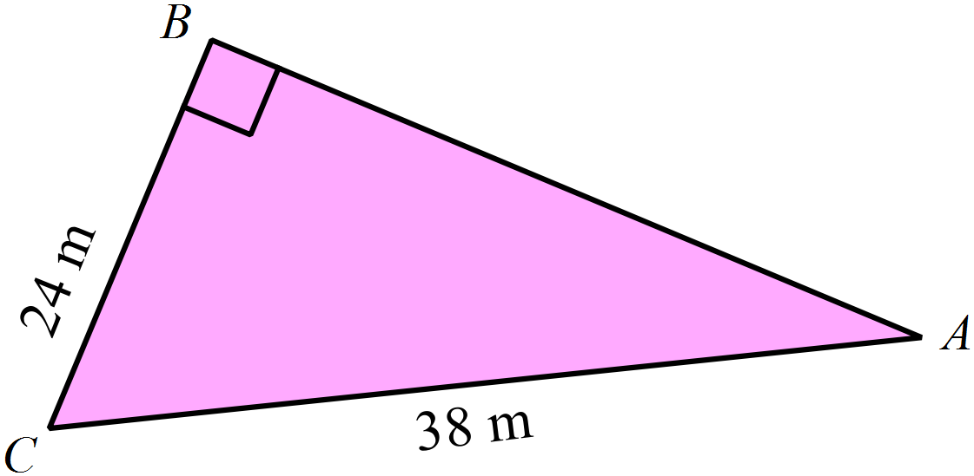Find the size of , correct to the nearest degree.

A. 32º
B. 39º
C. 51º
D. 58º
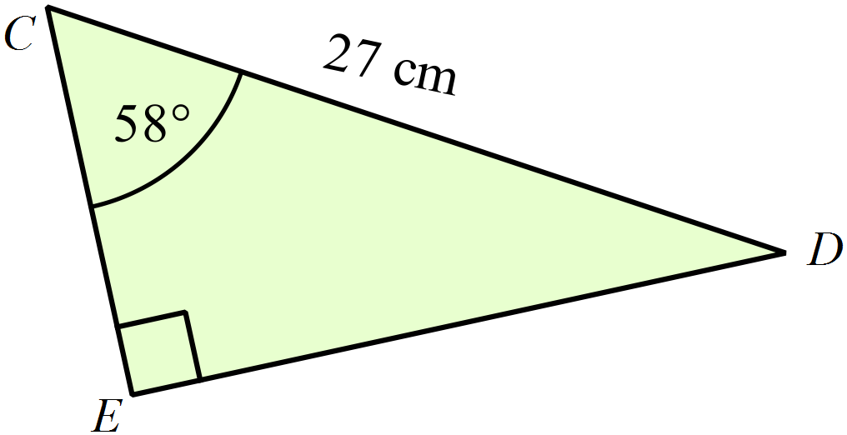Find the length of DE, correct to the nearest mm.
A. 14.3 cm
B. 22.9 cm
C. 43.2 cm
D. 51.0 cm
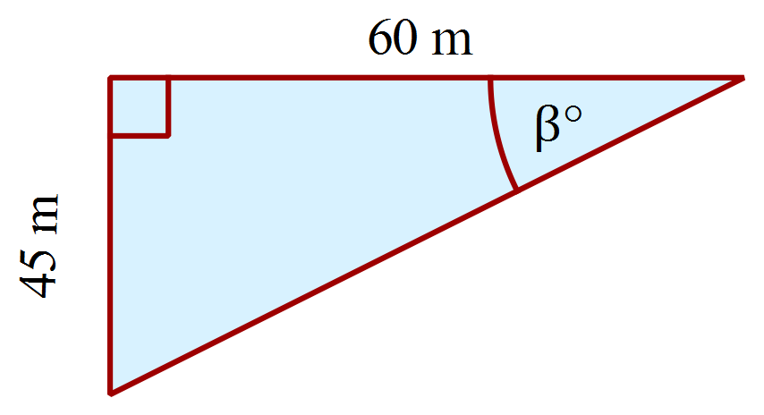Find the value of 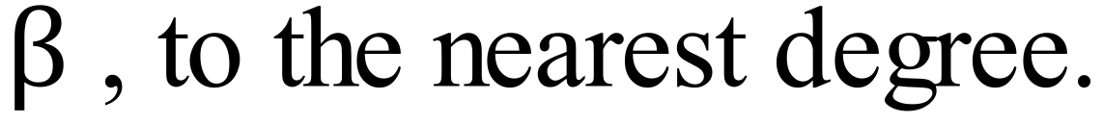
A. 37º
B. 41º
C. 49º
D. 53º
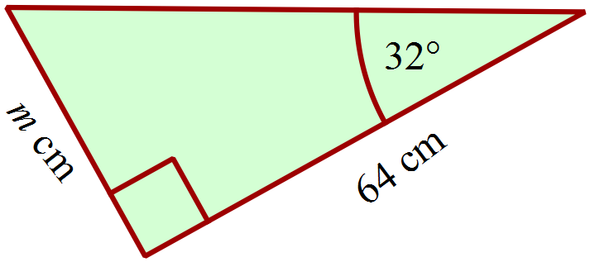Find the value of m, to the nearest 10th cm.
A. 33.9 cm
B. 40.0 cm
C. 54.3 cm
D. 75.5 cm
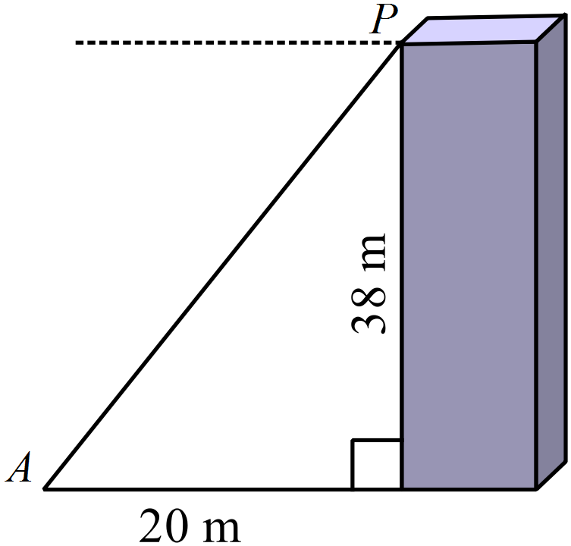Calculate the angle of elevation of P from A.

A. 28º
B. 32º
C. 58º
D. 62º

Find the height of the building, correct to the nearest 10 cm.
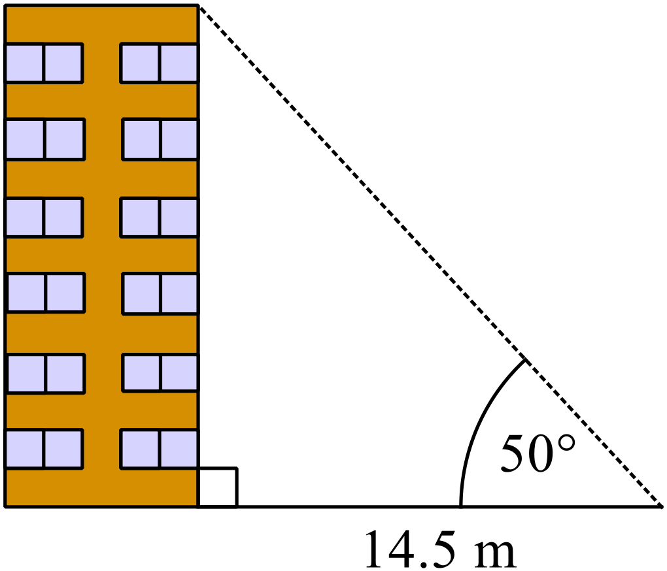
A. 11.1 m
B. 17.3 m
C. 18.9 m
D. 22.6 m

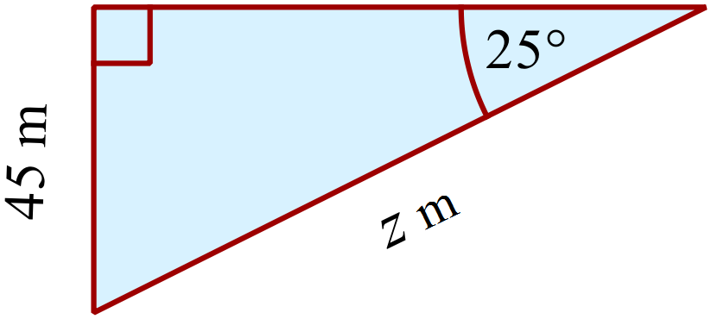Find the value of z correct to 1 decimal place.
A. 40.8 m
B. 49.7 m
C. 96.5 m
D. 106.5 m
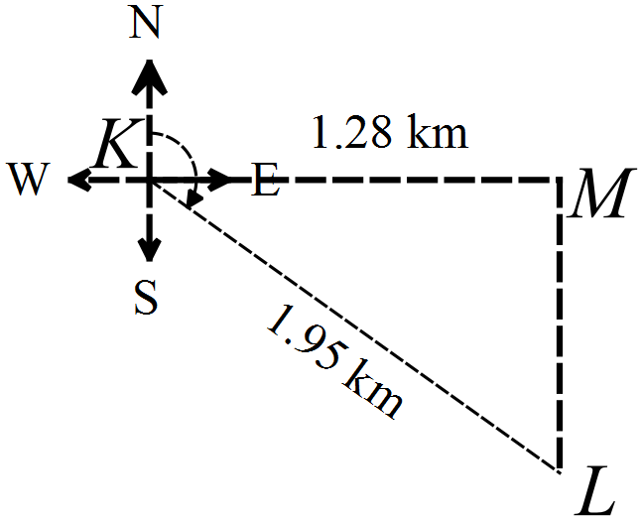What is the bearing of L from K ?

A. 049º
B. 131º
C. 139º
D. 221º

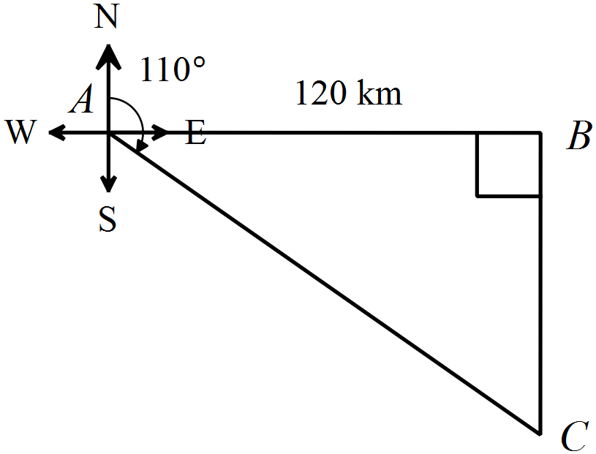Point B is 120 km due east of point A.
Point B is also due north of point C.
Point C is on a bearing 110º from point A.
What is the distance AC?
A. 128 km
B. 137 km
C. 330 km
D. 351 km
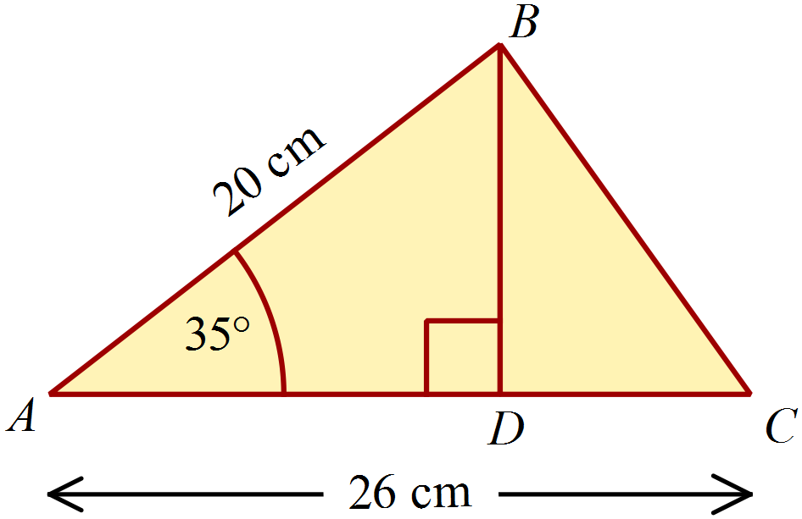Find the length of DC.

A. 9.6 cm
B. 12.0 cm
C. 14.5 cm
D. 16.4 cm

School Name
Mathematics 2017
Multiple Choice Answer Sheet
Right Triangle Trigonometry
Name _____________________________________________
Completely fill the response oval representing the most correct answer.
1. A B C D
2. A B C D
3. A B C D
4. A B C D
5. A B C D
6. A B C D
7. A B C D
8. A B C D
9. A B C D
10. A B C D
11. A B C D
12. A B C D
13. A B C D
14. A B C D
15. A B C D

School Name
Mathematics Test 2017
Year 9 | Right Triangle Trigonometry | Non Calculator Section
ANSWERS

Question | Working and Answer
 | 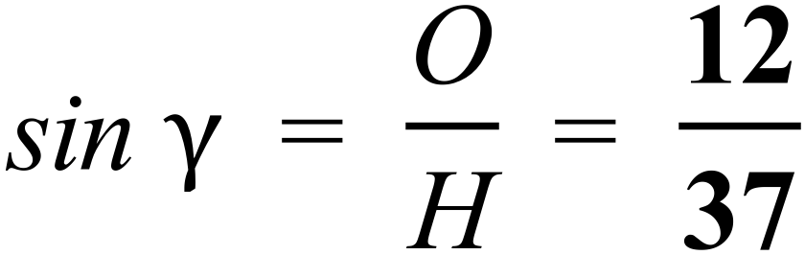
 | 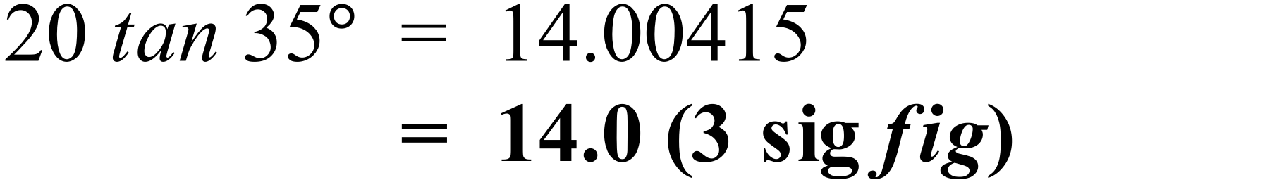
 | 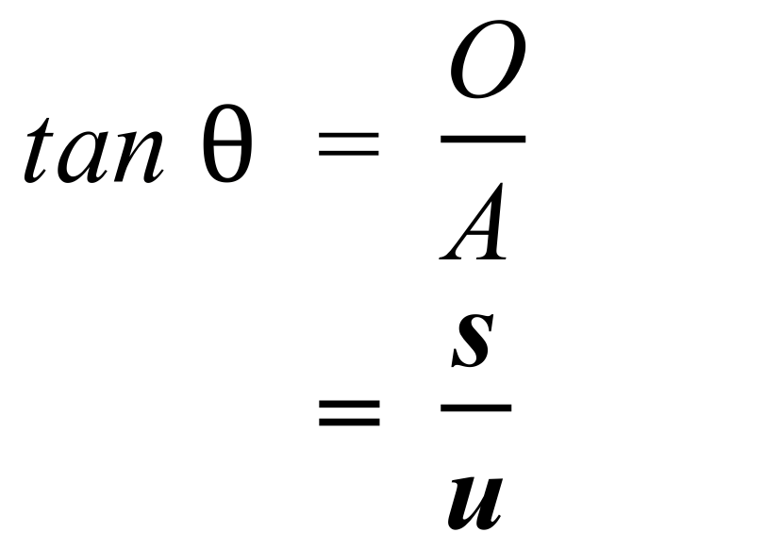
 | 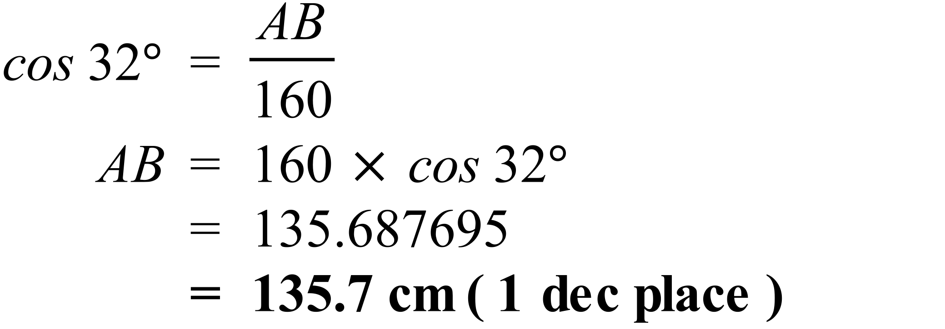
 | 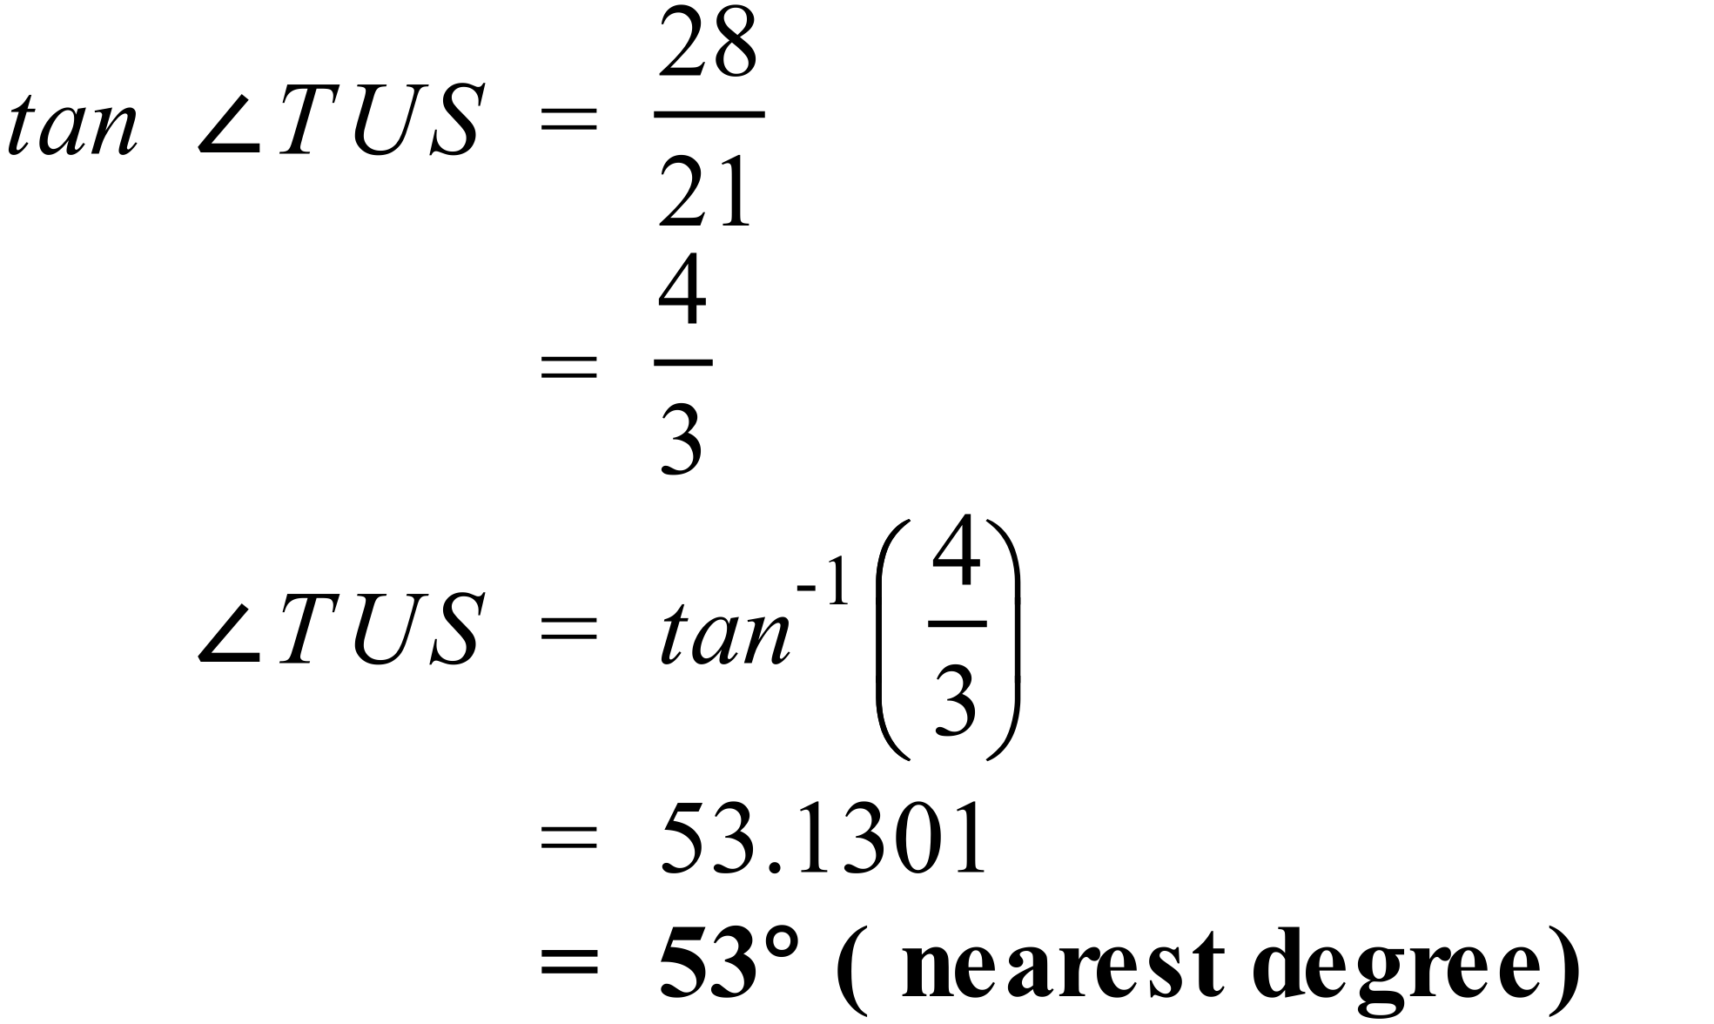
 | 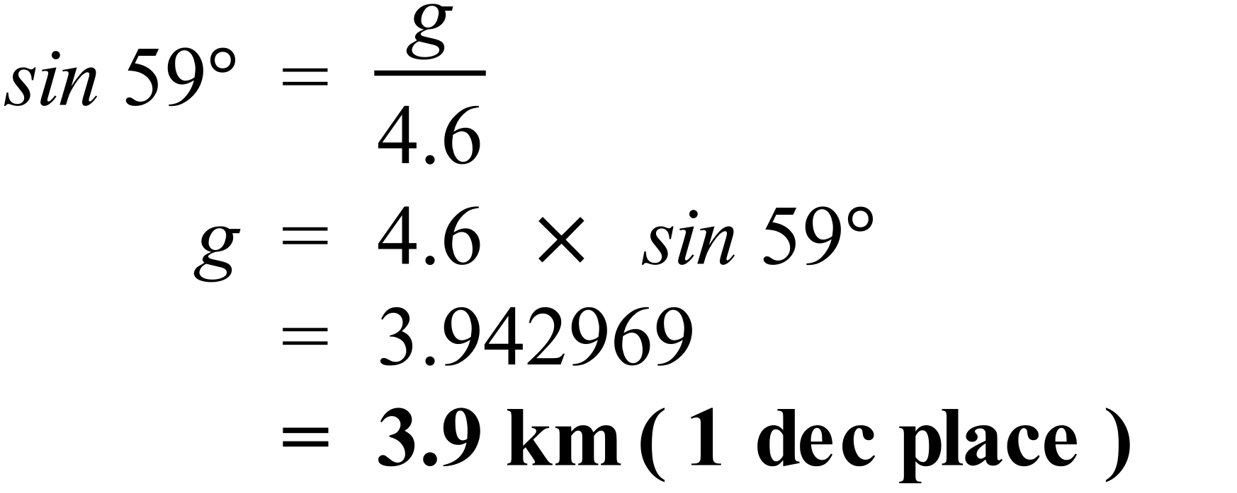
 | 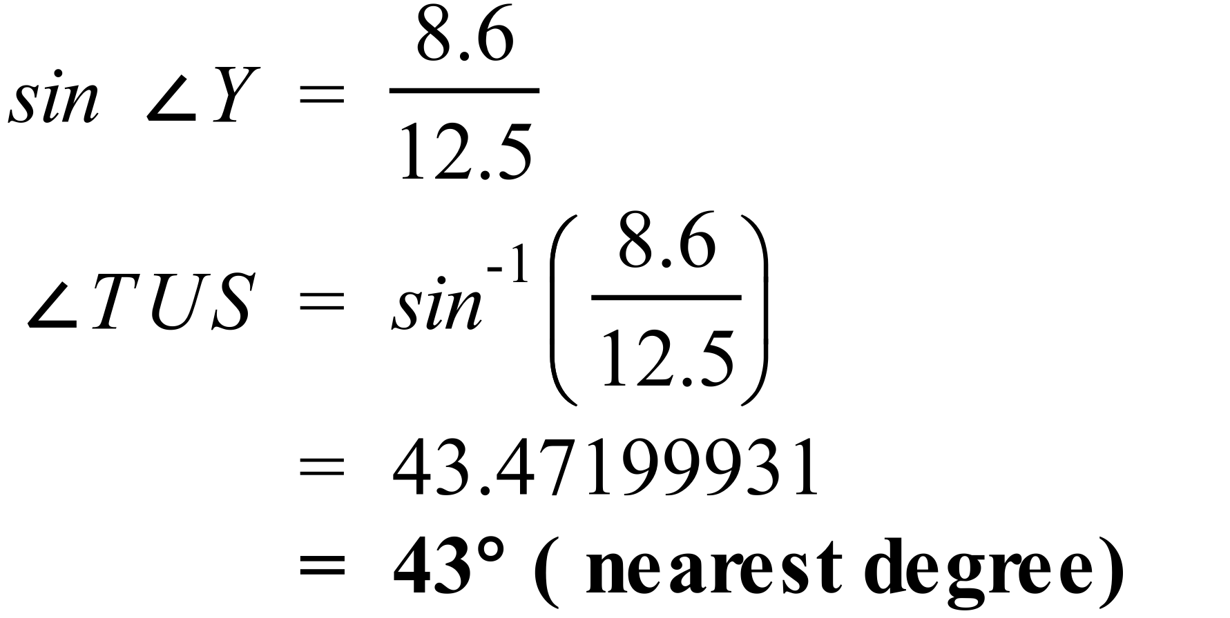
 | 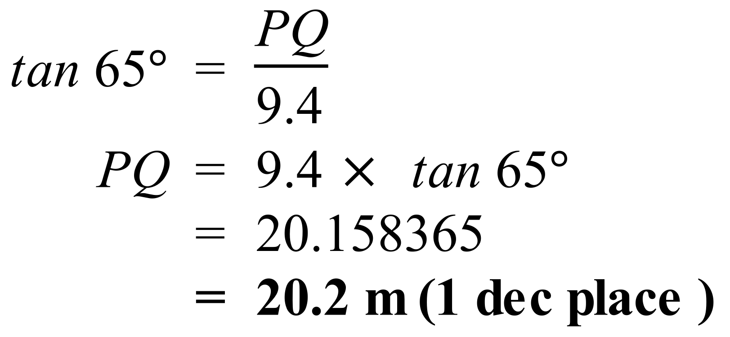
 | 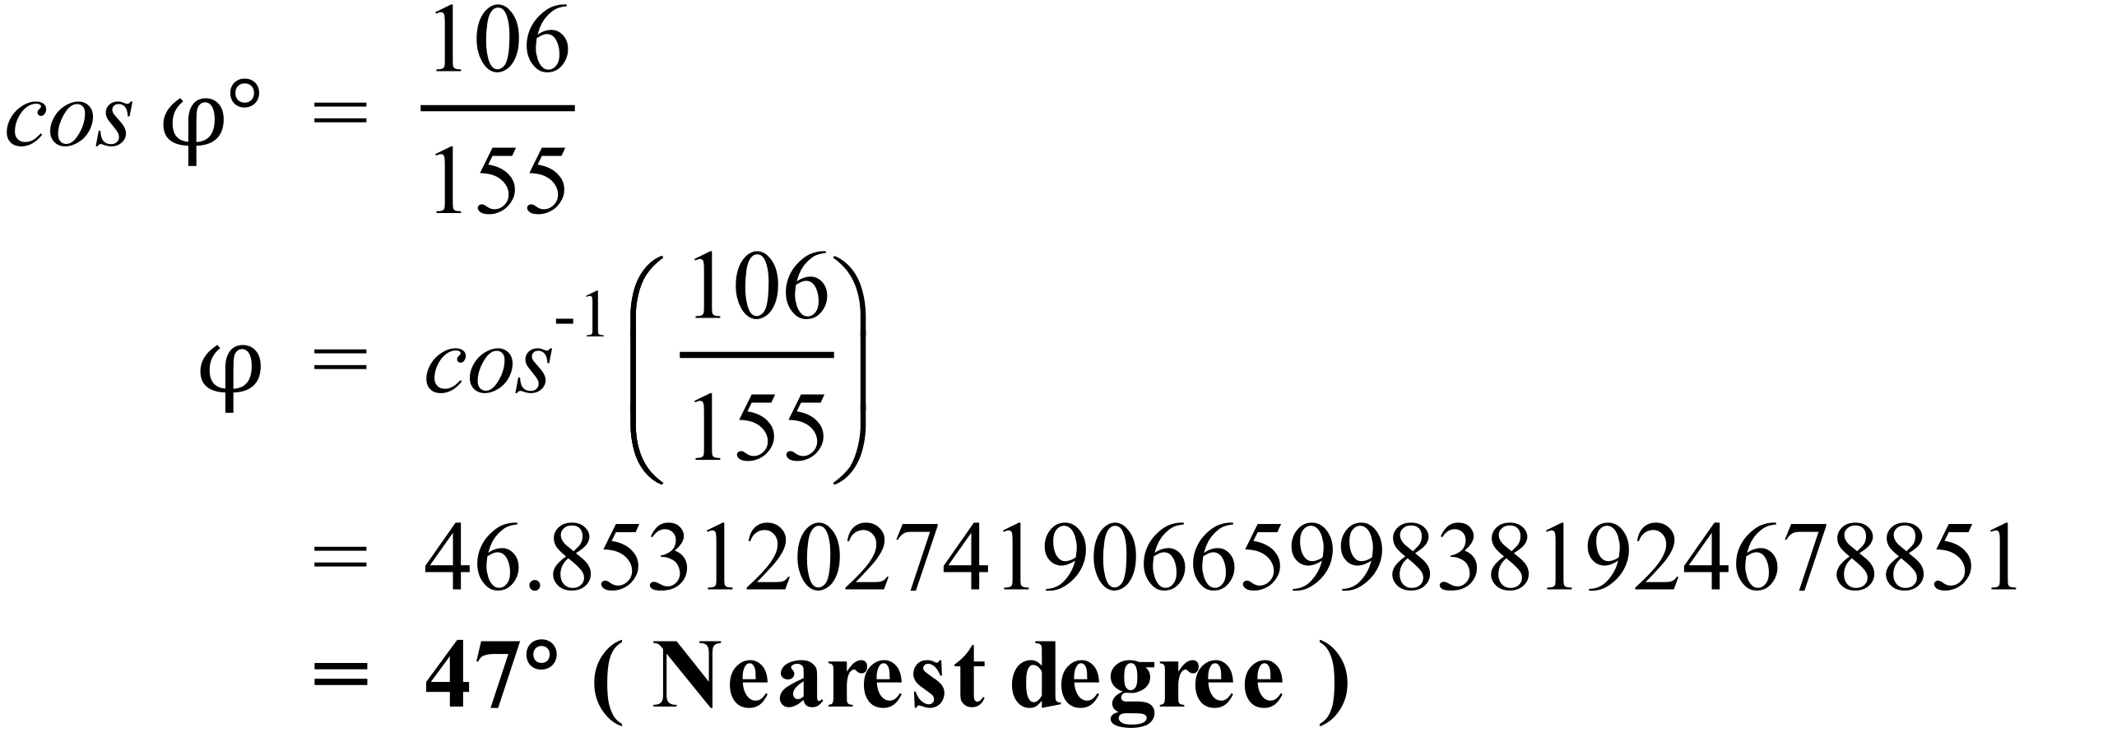
 | 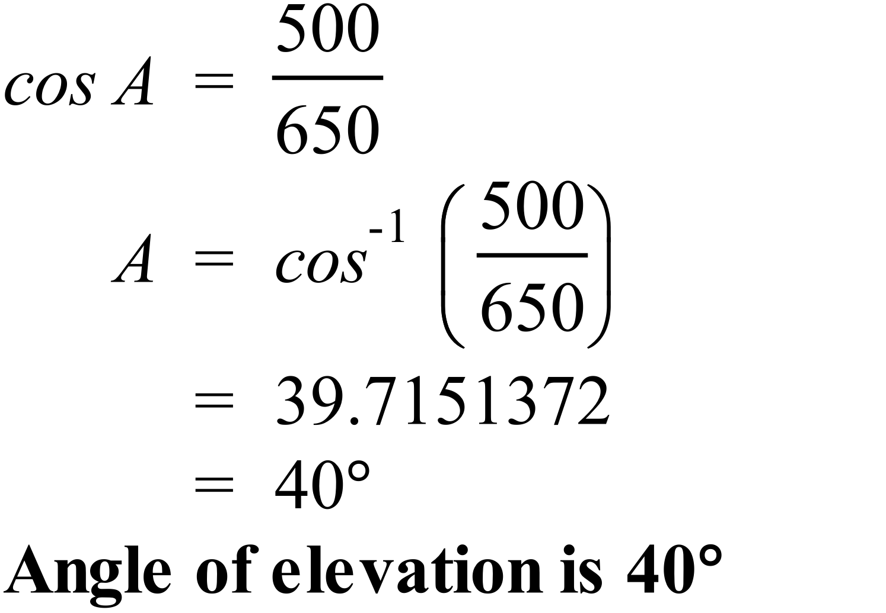
 | 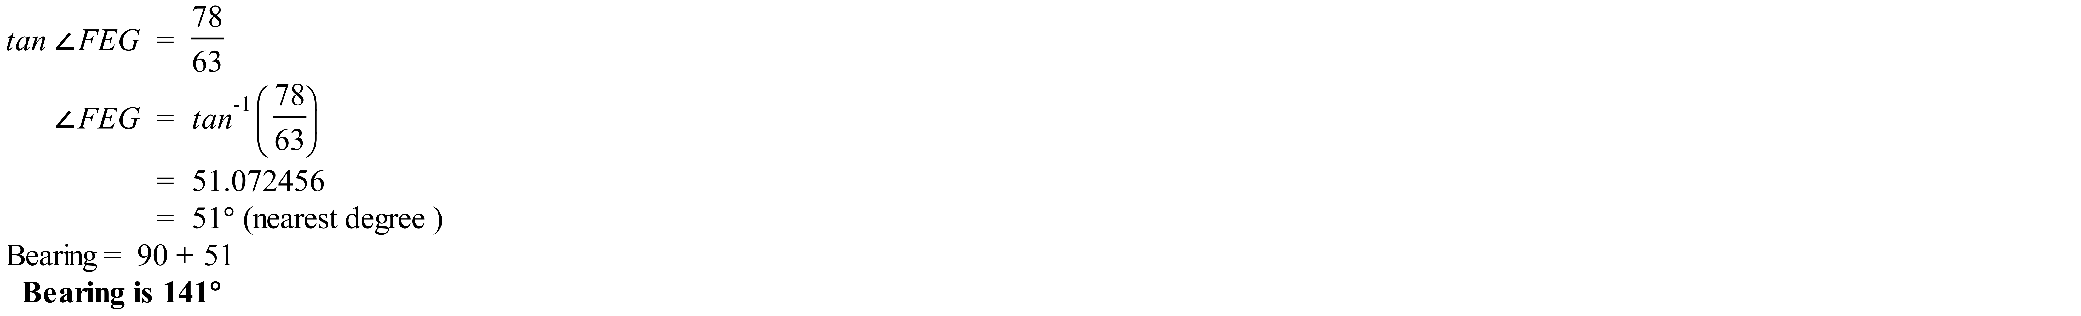
 | 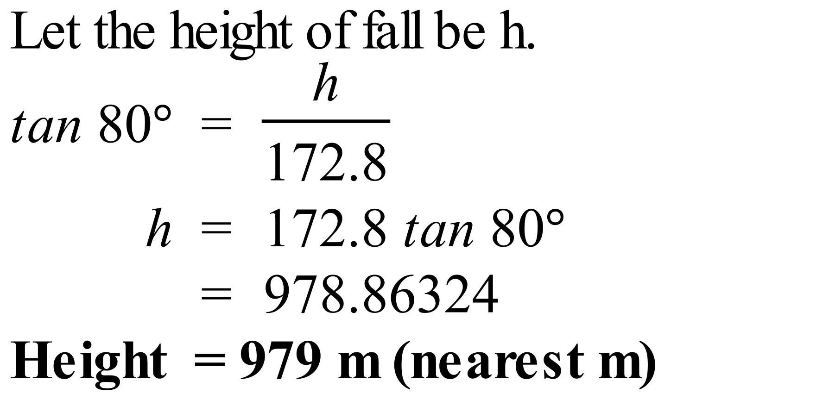
 | 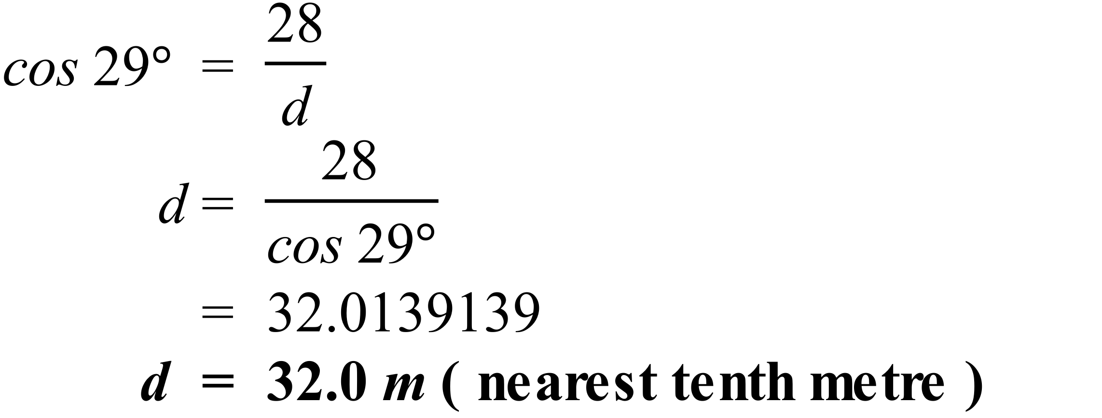
 | 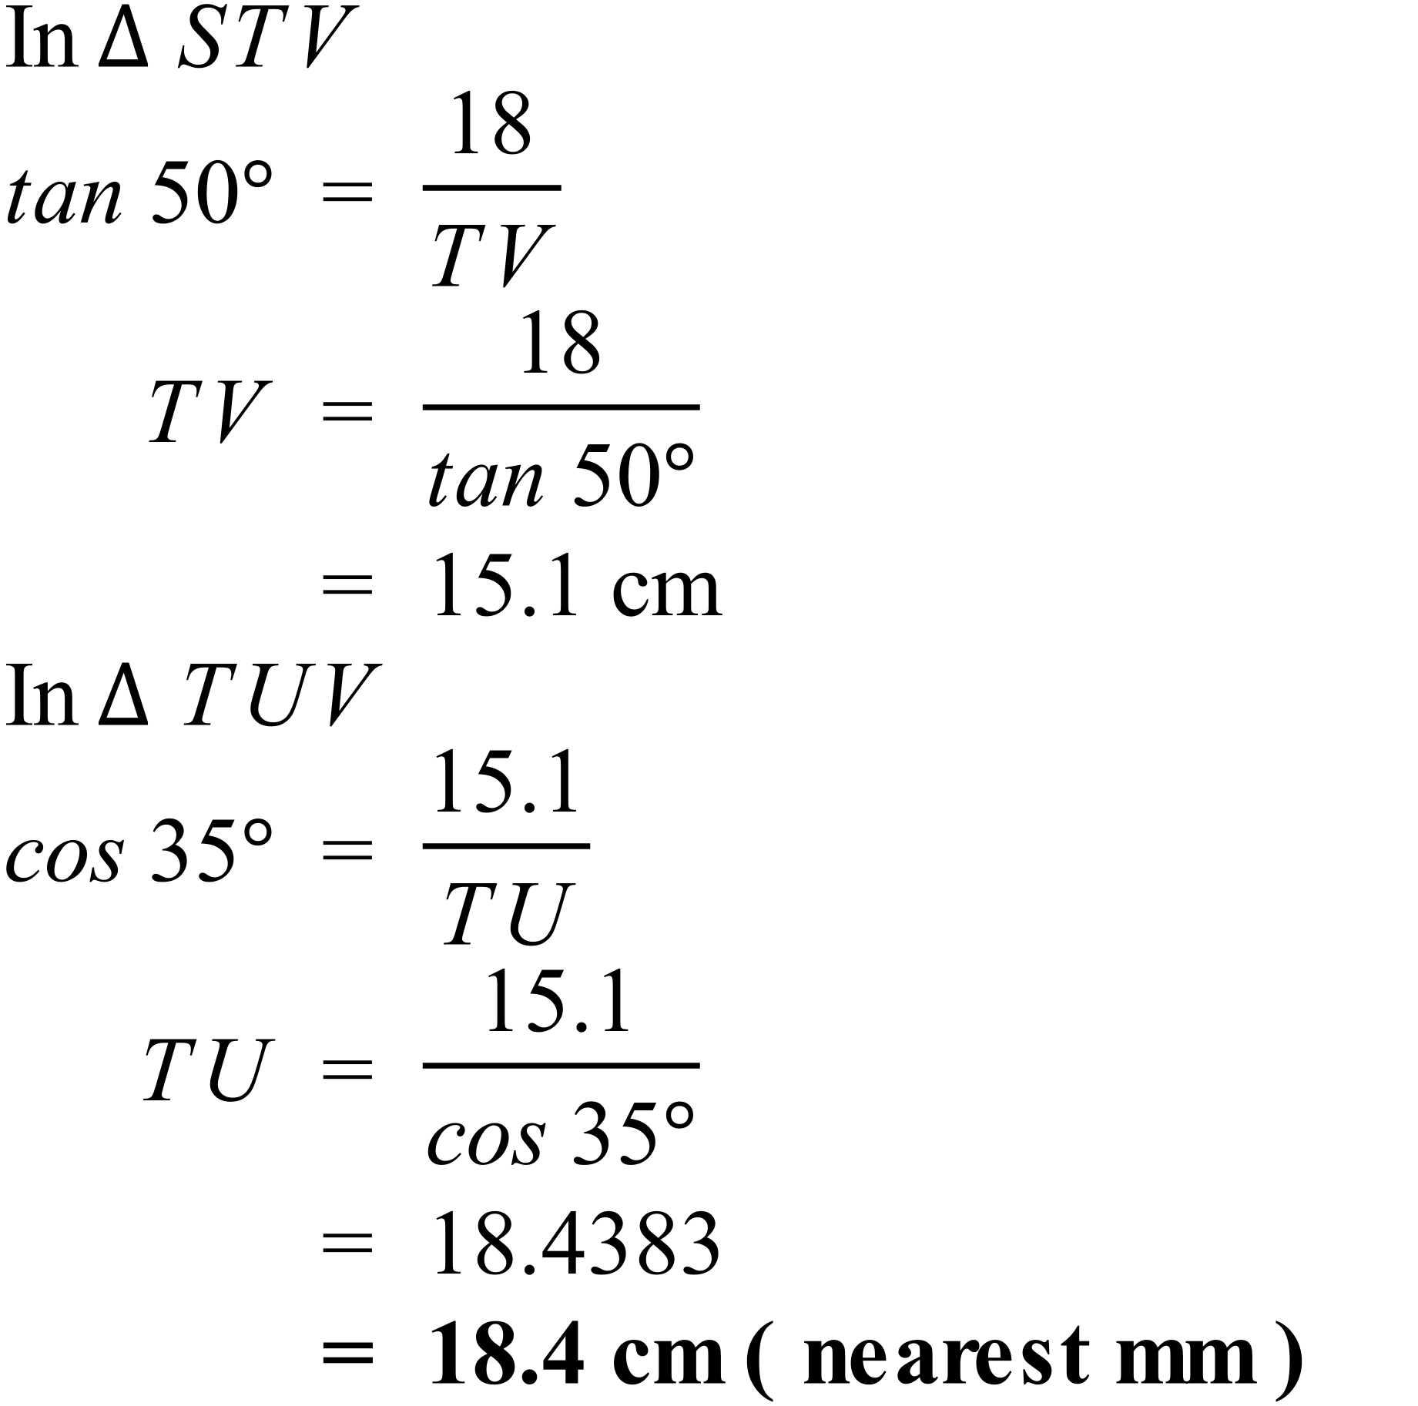
 | 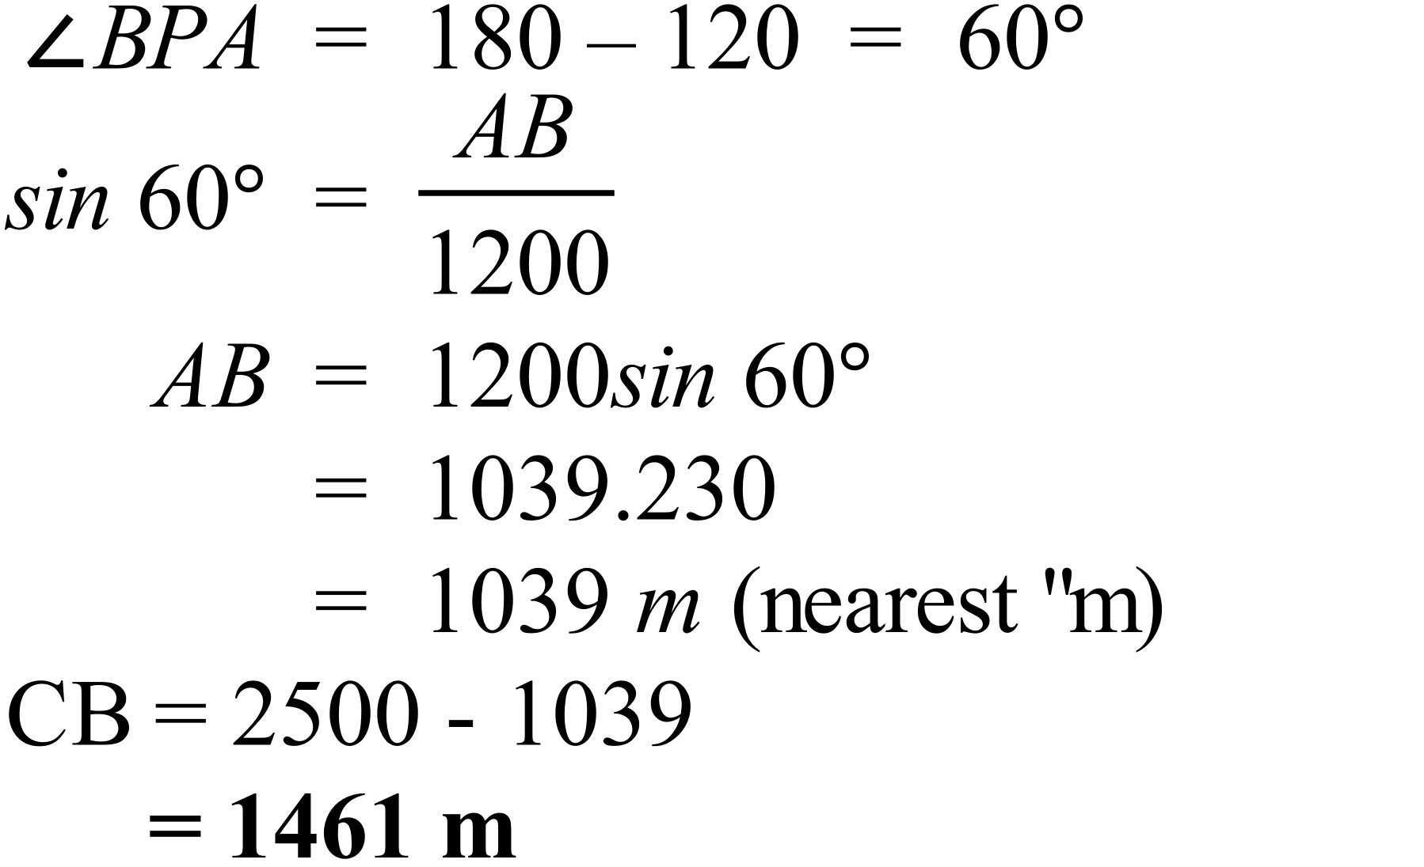

School Name
Mathematics Test 2017
Year 9 | Right Triangle Trigonometry | Calculator Allowed  Multiple Choice  Section

ANSWERS

Question | Working | M C Answer
 | 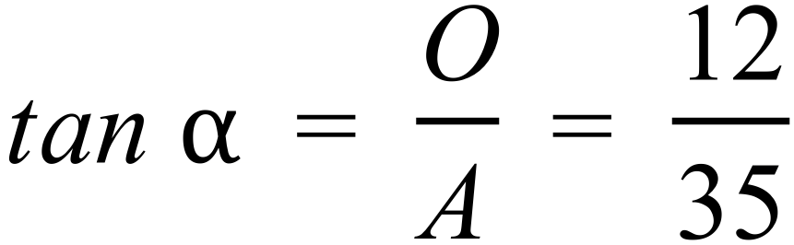 | A
 | 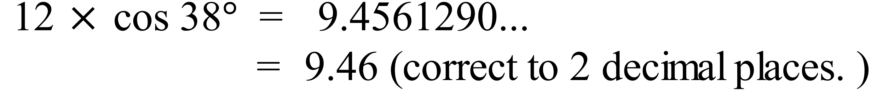 | B
 | 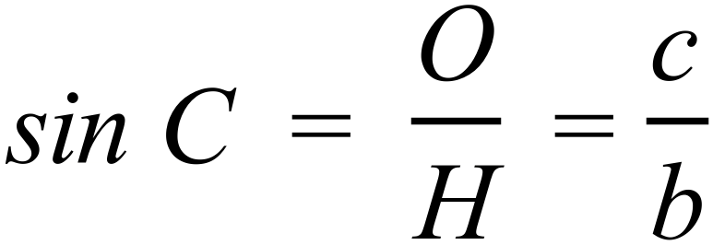 | C
 | 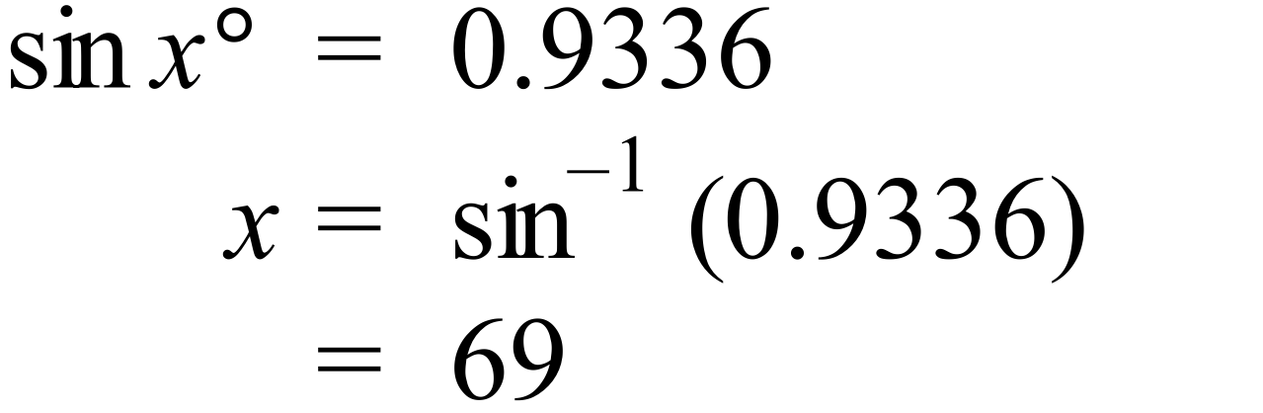 | D
 | 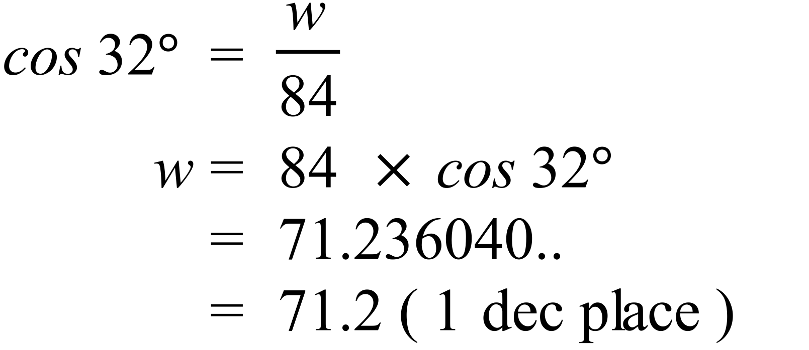 | C
 | 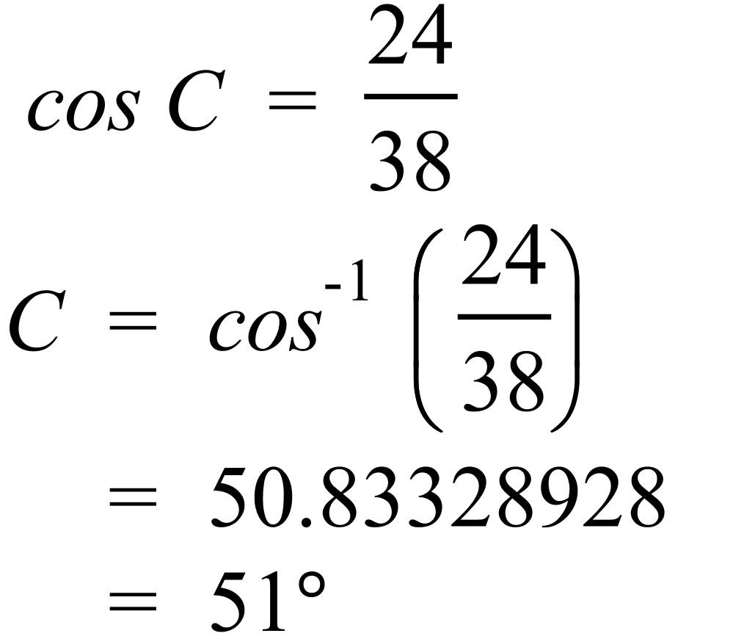 | C
 | 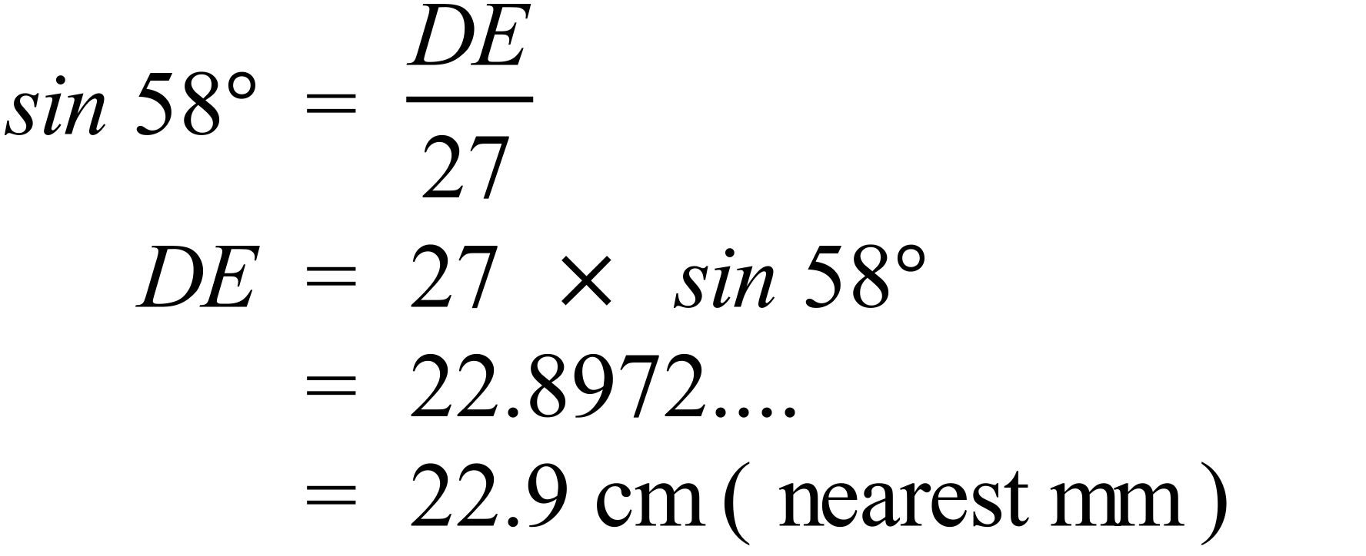 | B
 | 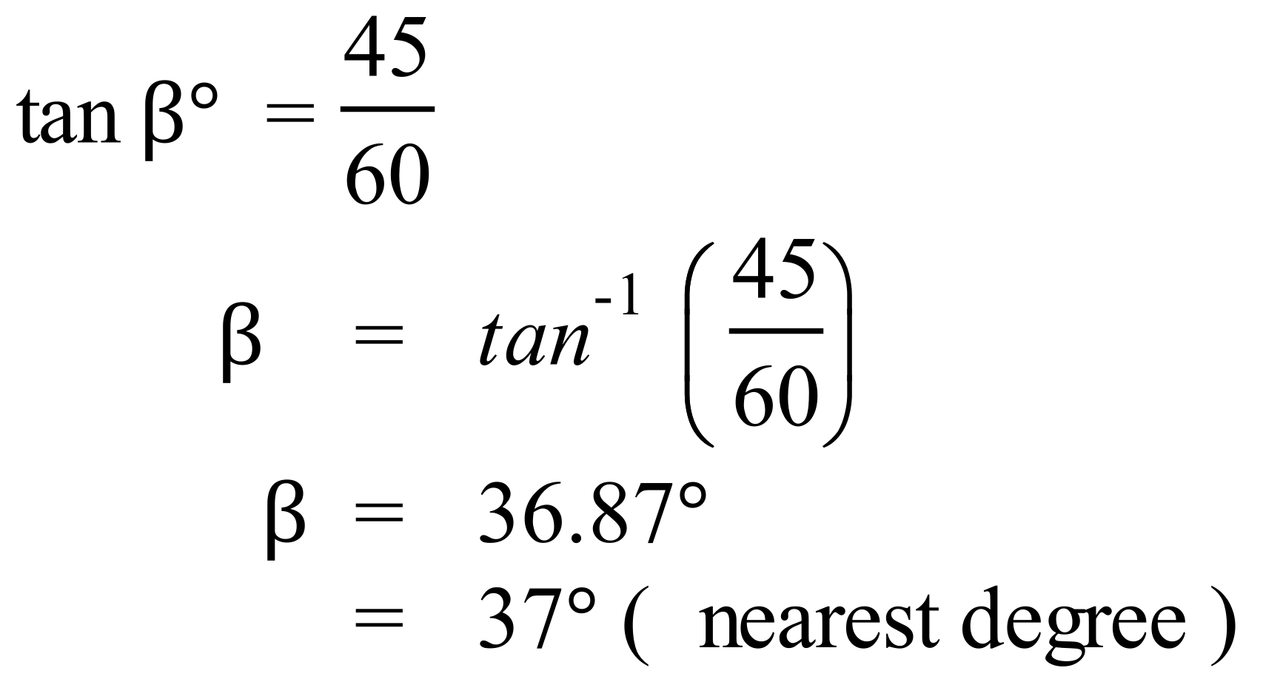 | A
 | 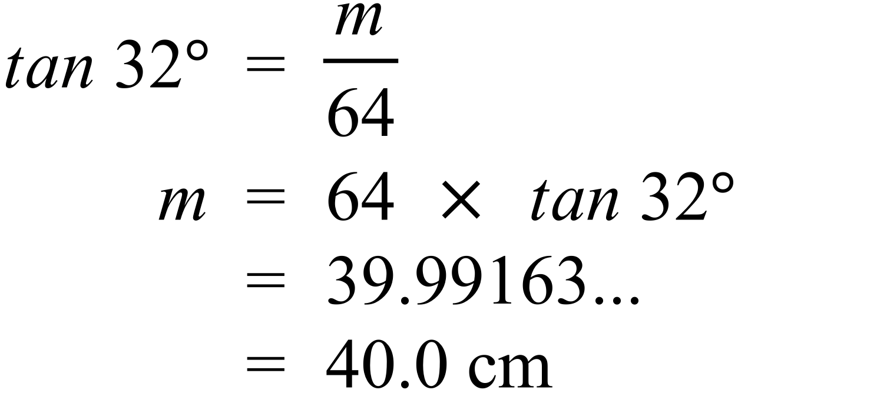 + | B
 | 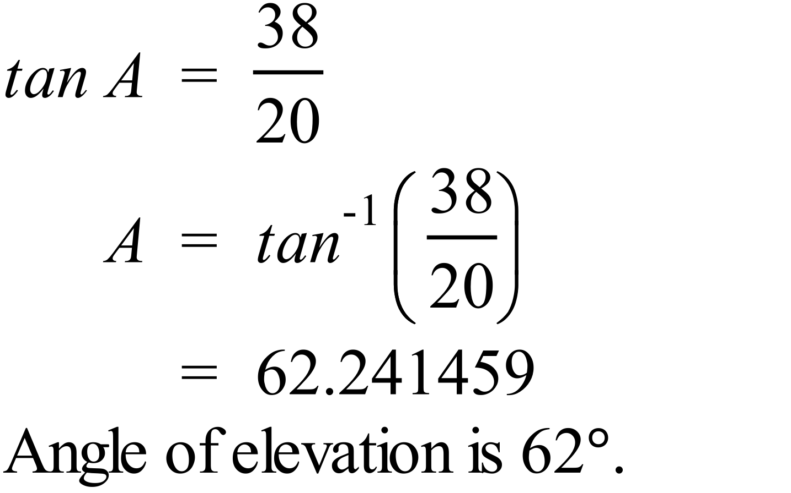 | D
 | 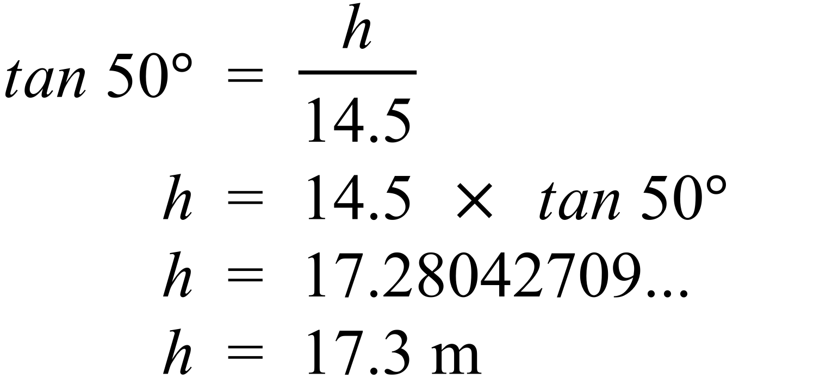 | B
 | 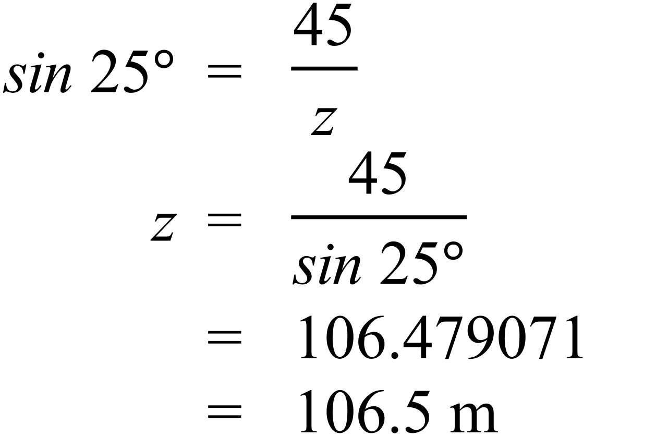 | D
 | 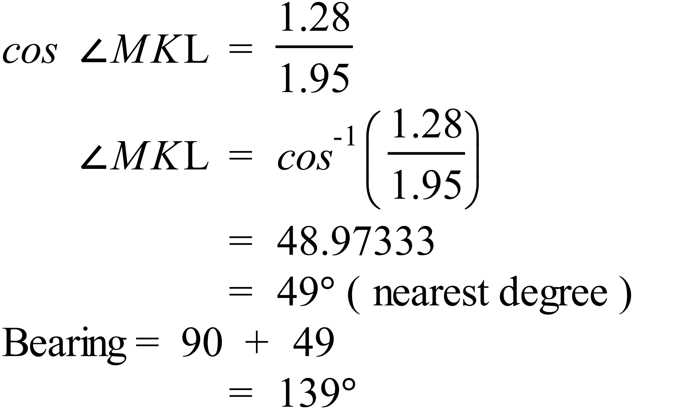 | C
 | 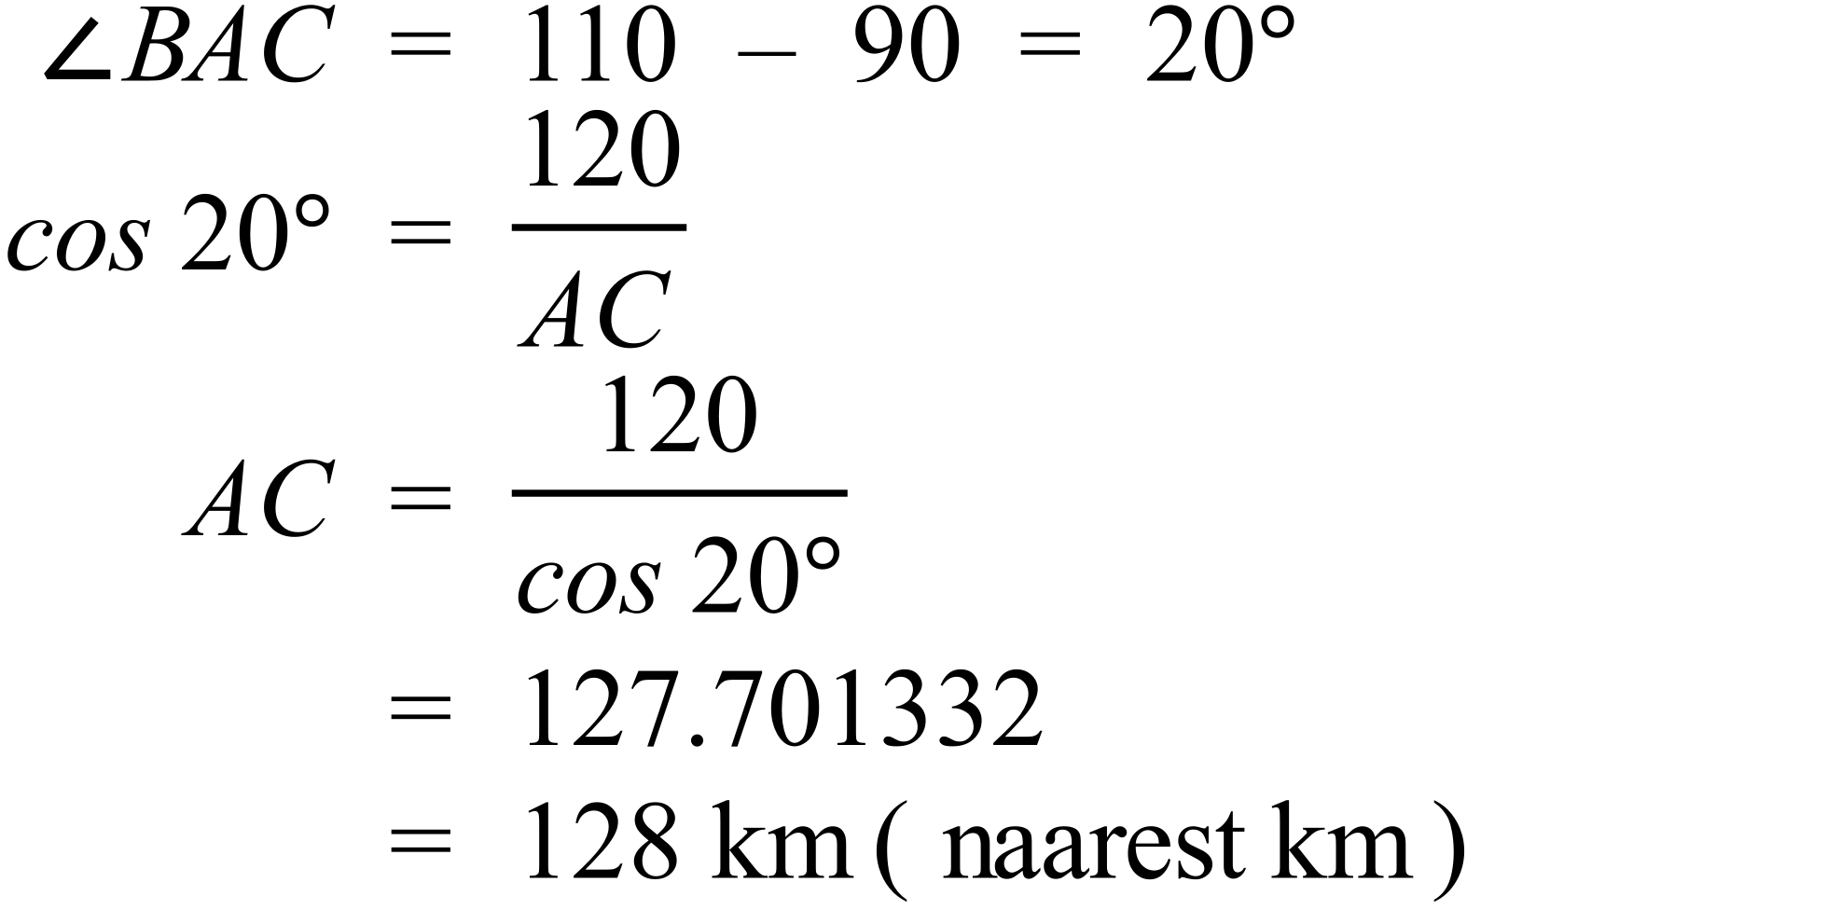 | A
 | 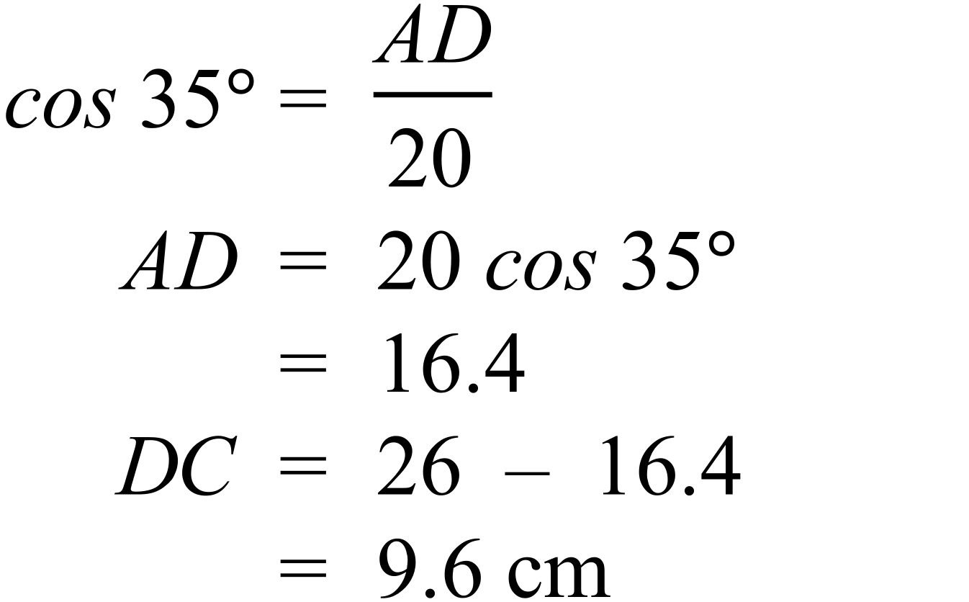 | A

School Name
Mathematics 2017
Multiple Choice Answer Sheet
Right Triangle Trigonometry
Name _____________________________________________
Completely fill the response oval representing the most correct answer.
1. A B C D
2. A B C D
3. A B C D
4. A B C D
5. A B C D
6. A B C D
7. A B C D
8. A B C D
9. A B C D
10. A B C D
11. A B C D
12. A B C D
13. A B C D
14. A B C D
15. A B C D

